**Getting started: How to log in to NIISQ Direct**  
  
Welcome! This guide will show you how to log in to your NIISQ Direct account. It’s written step-by-step to help you feel confident, even if you don’t use the internet often. You can go at your own pace.

**What you’ll need:**  
  
Before you begin, make sure you have the following ready:

* A device connected to the internet (like a phone, tablet, or computer)
* Your smart device with the Digital ID app
* Your Digital ID email address  
  *If you are unsure what a Digital ID is, there is some information at the end of this guide.

Tip: If you have someone who helps you with online tasks, you might want to ask them to go through this guide with you.

**Step-by-step: Logging in**  
Follow each step below.   
  
**Step 1: Go to the website**

* Open your internet browser (like Chrome, Safari, or Edge).
* Type in the website address: <https://niis.qld.gov.au/niisq-direct>.
* Press Enter on your keyboard.

**Step 2: Log in to your NIISQ Direct account**

* Look for a button that says “Log in to NIISQ Direct.”
* Click the button once.

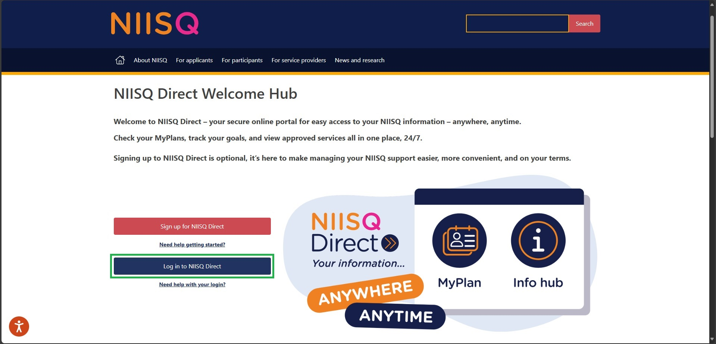

**Step 3: Confirm your details**

* Select your Digital ID provider and log in following their prompts.

**Step 4: You’re in!**

* After logging in, you’ll see the NIISQ Direct home page.
* From here, you can view your MyPlan, providers, approved services and more.

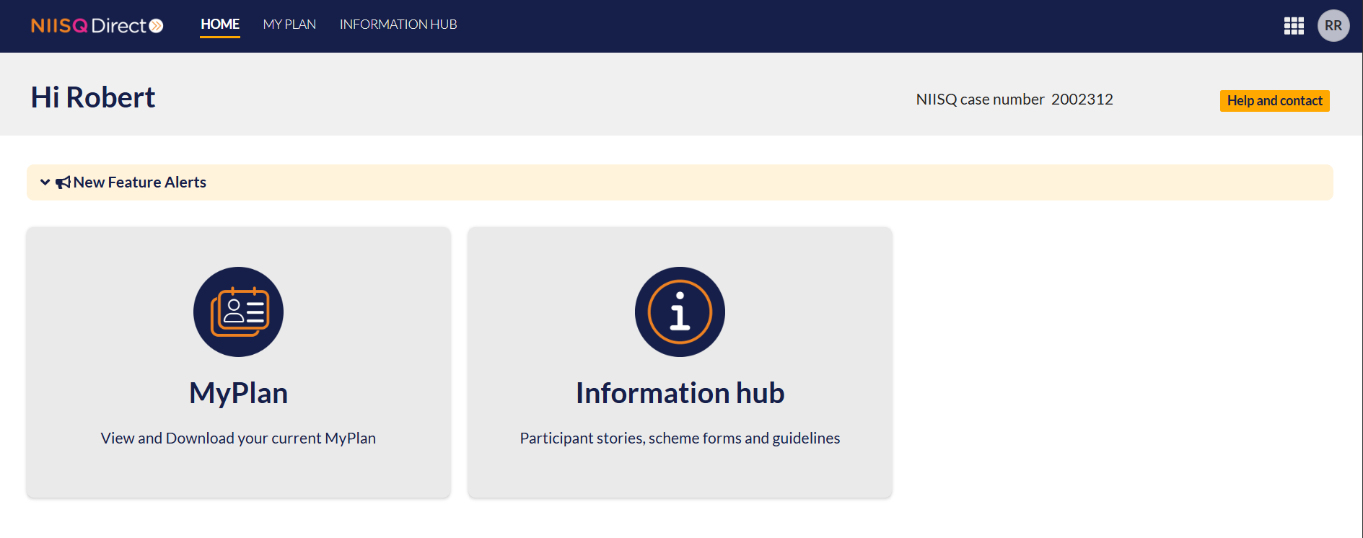

**Important note: Trouble logging in?**

Sometimes our team might need to do an update or maintenance to the portal, which means you might not be able to log in right away. This is temporary — just try again later or contact [help@niis.qld.gov.au](mailto:help@niis.qld.gov.au) if you have any questions.

**Need help?**  
  
If you need help at any time:

* Email us at [help@niis.qld.gov.au](mailto:help@niis.qld.gov.au). We’ll get back to you as soon as possible.
* You can also ask someone you trust to help you with this guide.

**Digital ID hints and tips**

NIISQ Direct uses Digital ID to securely sign you into our portal. This is used by Australian and Queensland government agencies and providers and helps you to access your information.

Please note, NIISQ Direct does not accept QGOV or QDI Digital IDs.

**What is a Digital ID?**

* A Digital ID is a secure and easy way to prove who you are online.

**What if I don’t have a Digital ID?**

* If you don’t currently have a Digital ID, you’ll need to create one before you can login to NIISQ Direct.
* It’s free and easy to do.
* Go to <https://www.qld.gov.au/qdifaq> for advice on how to set up a Digital ID with a Digital ID provider.

**What is an identity strength?**

* Identity strength is like a trust level for your Digital ID. It's a way of showing how sure the system is that you are who you say you are.
* To be able to sign into NIISQ Direct, your identity strength needs to be set as ‘standard’ or higher.