**Getting started: How to access your MyPlans**  
  
Welcome! This guide will help you find and view your current MyPlan on NIISQ Direct. It’s easy to follow, and you can go at your own pace. If you need help, a support person or trusted friend can follow along with you.

**What you’ll need:**  
  
Before you begin, make sure you have the following ready:

* A device connected to the internet (like a phone, tablet, or computer)
* Your smart device with the Digital ID app
* Your Digital ID email address  
  *If you are unsure what a Digital ID is, there is some information at the end of this guide.

Tip: If you have someone who helps you with online tasks, you might want to ask them to go through this guide with you.

**Step-by-step: How to view and download your MyPlan**  
Follow each step below.   
  
**Step 1: Go to the website**

* Open your internet browser (like Chrome, Safari, or Edge)
* Type in the website address: <https://niis.qld.gov.au/niisq-direct>.
* Press Enter on your keyboard.

**Step 2: Log in to your NIISQ Direct account**

* Look for a button that says “Log in to NIISQ Direct”
* Click the button once.

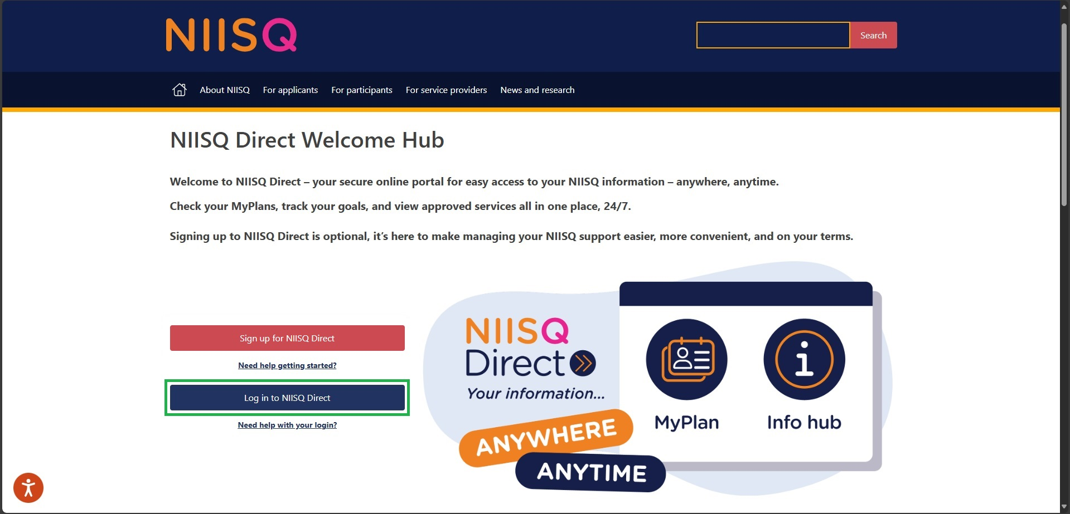

**Step 3: Go to the MyPlan section**

* To access the MyPlan section, click on the “MyPlan” tile on NIISQ Direct’s home page
* You can also click on the “MyPlan” tab at the top of the screen. Either way is ok!

tile

tab

**Step 4: Exploring your current MyPlan**

Once you click on the MyPlan tile or tab, NIISQ Direct will take you to your current, approved MyPlan. Here you can see information about your plan, including:

* Your current plan timeframe
* The last date your plan was updated
* Your approved services and service providers
* The description of each approved service, and
* The goals you and your providers are working towards.

**Important note: What if you don’t see a MyPlan?**

If you are **new to NIISQ** and have not created a MyPlan yet, or your current MyPlan is being **updated or reviewed**, you won’t be able to see any of your providers, services or goals right away.

That’s okay. It just means your MyPlan is being worked on by your Support Planner. You can:

* Try again later, or
* Contact your Support Planner if you have any questions.

**Optional: Downloading your current MyPlan**

* If you want to download a copy of your MyPlan, look for the button that says “Download MyPlan” in the top right corner of your current MyPlan screen.
* Click the button and choose where to save it (it will save as a PDF document).

Tip: You could also print your MyPlan if you would like a paper copy.

**Optional: View your current goals**

NIISQ Direct gives you quick and easy access to your current goals, as discussed with your Support Planner and providers.

* Look at the menu on the left side of your current MyPlan screen.
* You will see an option for “My goals.” Click this link.
* A new page will open, which lists the goals you have created for your current MyPlan.
* This is a great way to review and track your progress.

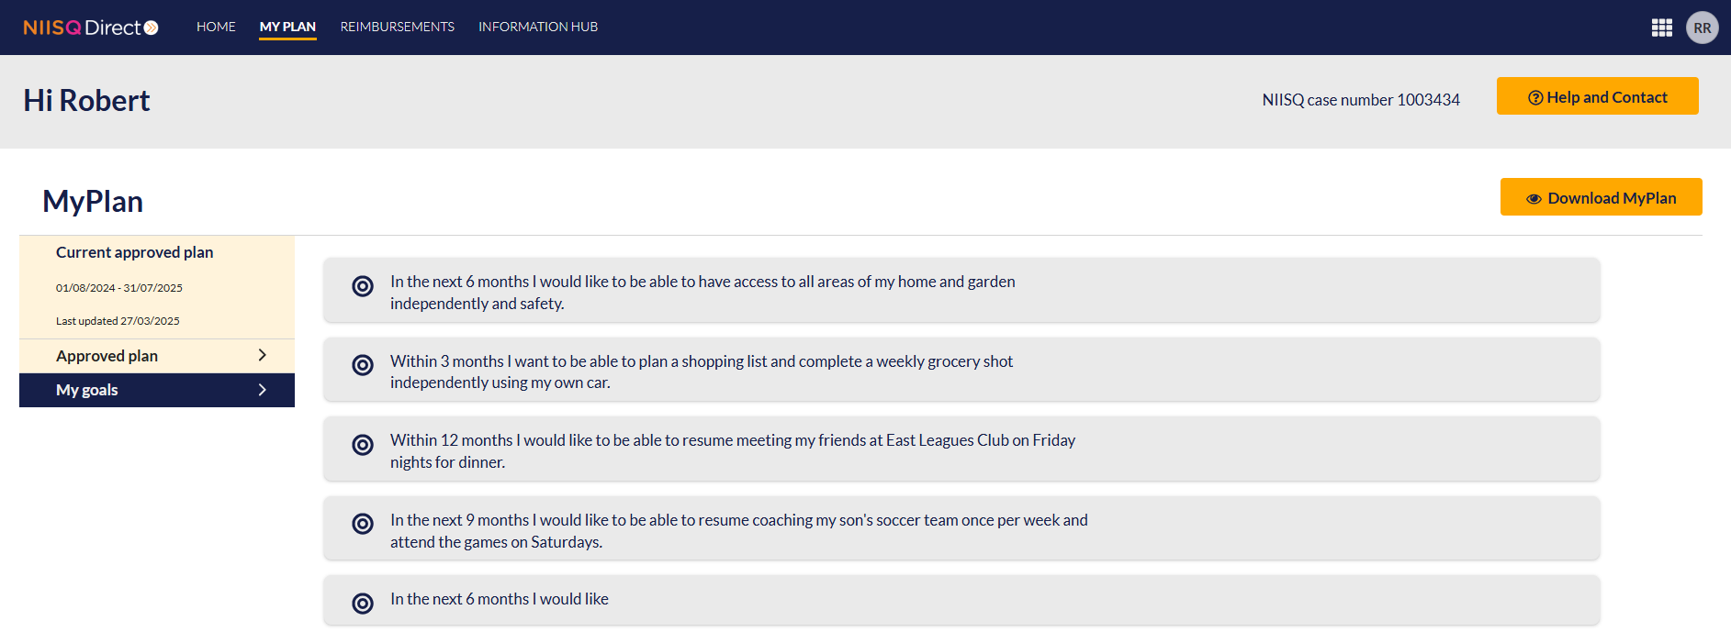

**Need help?**  
  
If you need help at any time:

* Email us at [help@niis.qld.gov.au](mailto:help@niis.qld.gov.au). We’ll get back to you as soon as possible.
* You can also ask someone you trust to help you with this guide.

**Digital ID hints and tips**

NIISQ Direct uses Digital ID to securely sign you into our portal. This is used by Australian and Queensland government agencies and providers and helps you to access your information.

Please note, NIISQ Direct does not accept QGOV or QDI Digital IDs.

**What is a Digital ID?**

* A Digital ID is a secure and easy way to prove who you are online.

**What if I don’t have a Digital ID?**

* If you don’t currently have a Digital ID, you’ll need to create one before you can login to NIISQ Direct.
* It’s free and easy to do.
* Go to <https://www.qld.gov.au/qdifaq> for advice on how to set up a Digital ID with a Digital ID provider.

**What is an identity strength?**

* Identity strength is like a trust level for your Digital ID. It's a way of showing how sure the system is that you are who you say you are.
* To be able to sign into NIISQ Direct, your identity strength needs to be set as ‘standard’ or higher.