Getting started: Navigating the MyDetails section
Welcome! This guide will help you find, view, and edit your details on NIISQ Direct. It’s easy to follow, and you can go at your own pace. If you need help, a support person or trusted friend can follow along with you.

What you’ll need:
Before you begin, make sure you have the following ready:
- A device connected to the internet (like a phone, tablet, or computer)
- Your smart device with the Digital ID app
- Your Digital ID email address
  - If you are unsure what a Digital ID is, there is some information at the end of this guide.
Tip: If you have someone who helps you with online tasks, you might want to ask them to go through this guide with you.

Step-by-step: How to view your details
Follow each step below.
Step 1: Go to the website
- Open your internet browser (like Chrome, Safari, or Edge)
- Type in the website address: https://niis.qld.gov.au/niisq-direct/.
- Press Enter on your keyboard.
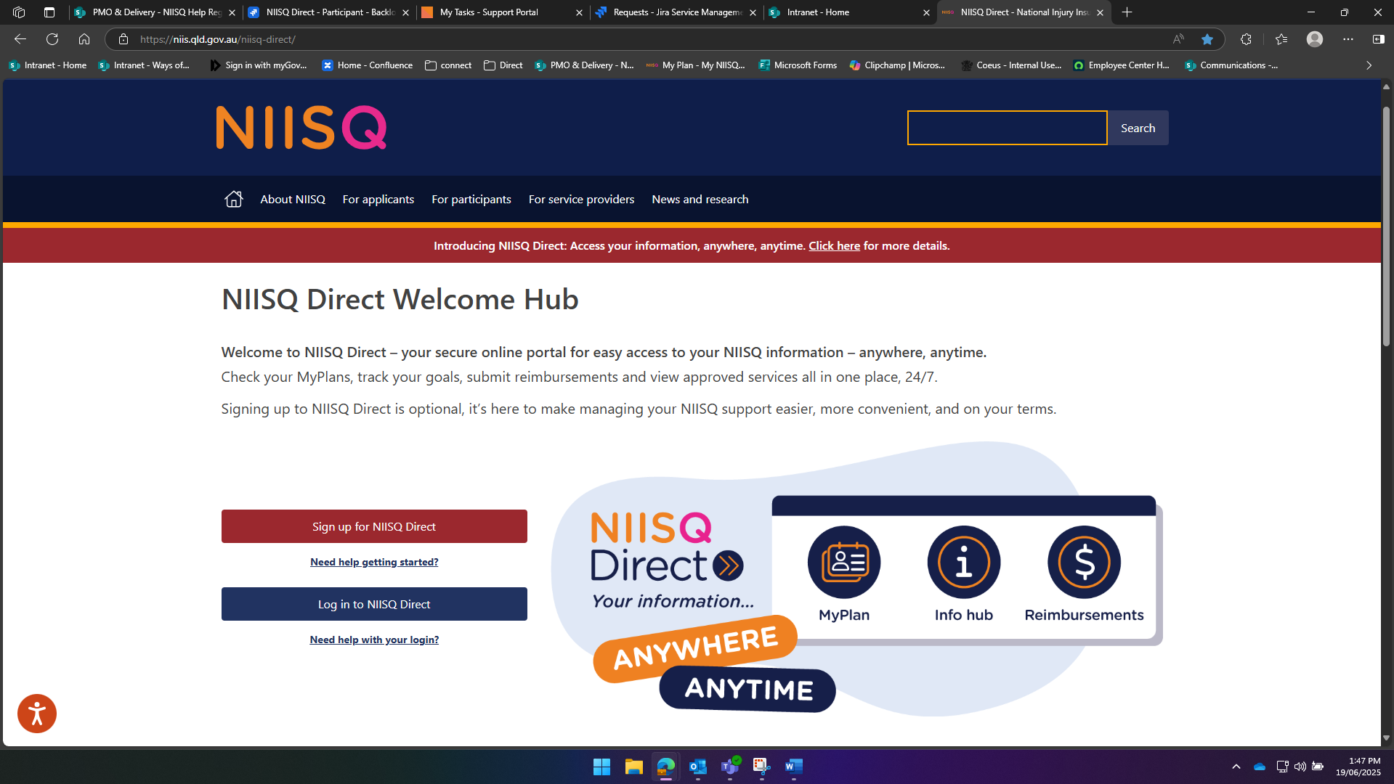

Step 2: Log in to your NIISQ Direct account
- Look for a button that says “Log in to NIISQ Direct”
- Click the button once.
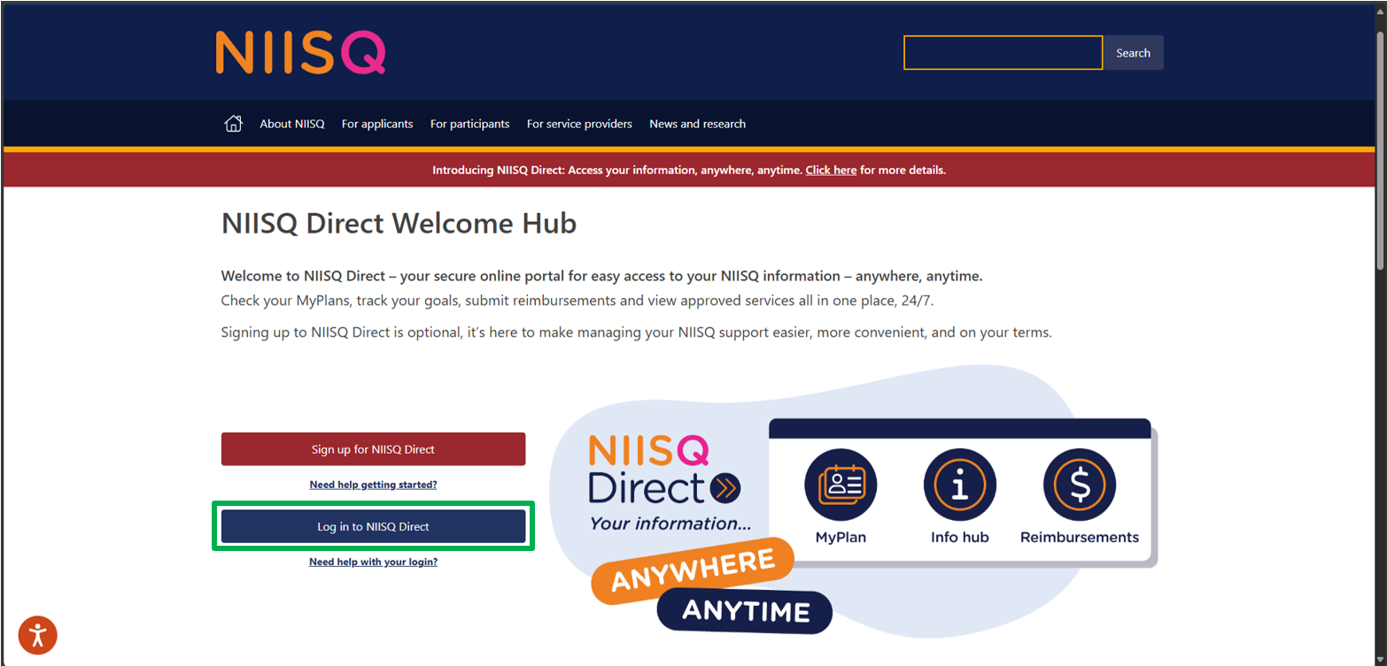
Step 3: Go to the MyDetails section
- To access the MyDetails section, click on the “MyDetails” tile on NIISQ Direct’s home page
- You can also click on the “MyDetails” tab at the top of the screen. Either way is ok!
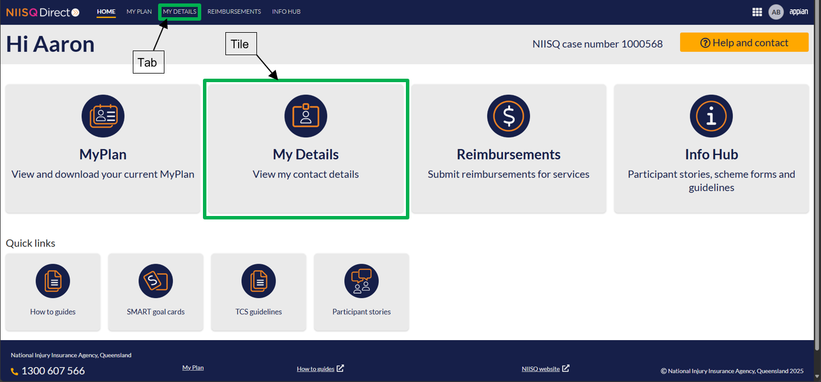

Step 4: Exploring your details
Once you click on the MyDetails tile or tab, NIISQ Direct will take you to your current details. Here you can see information about your details, including your:
- contact information
- addresses
- payment details
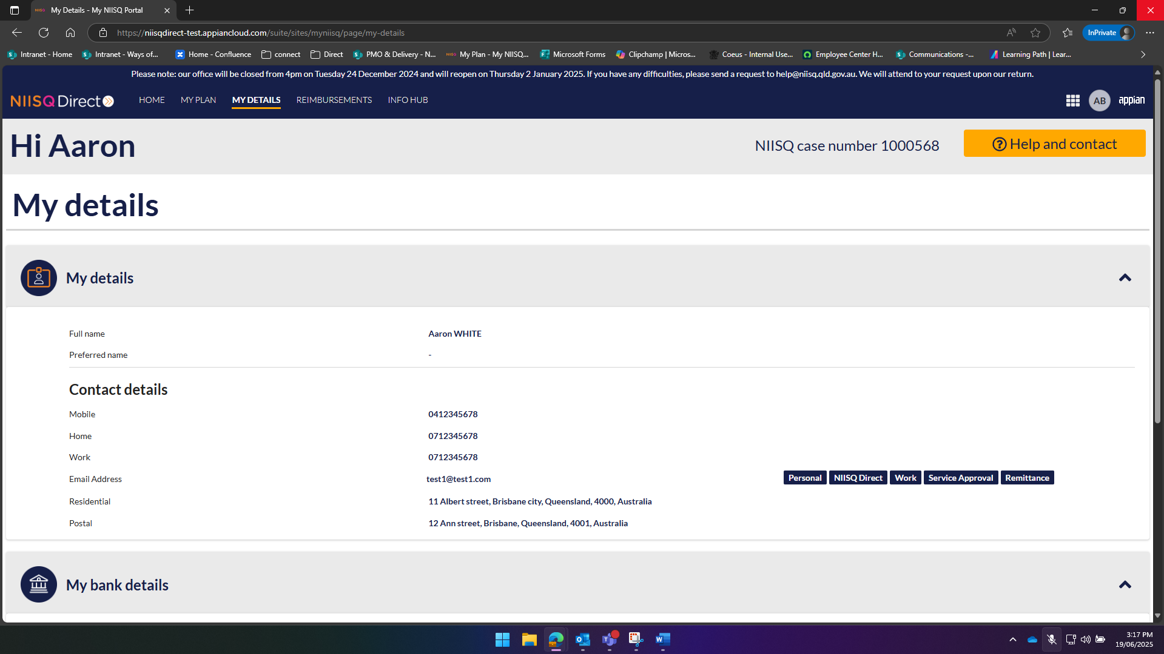
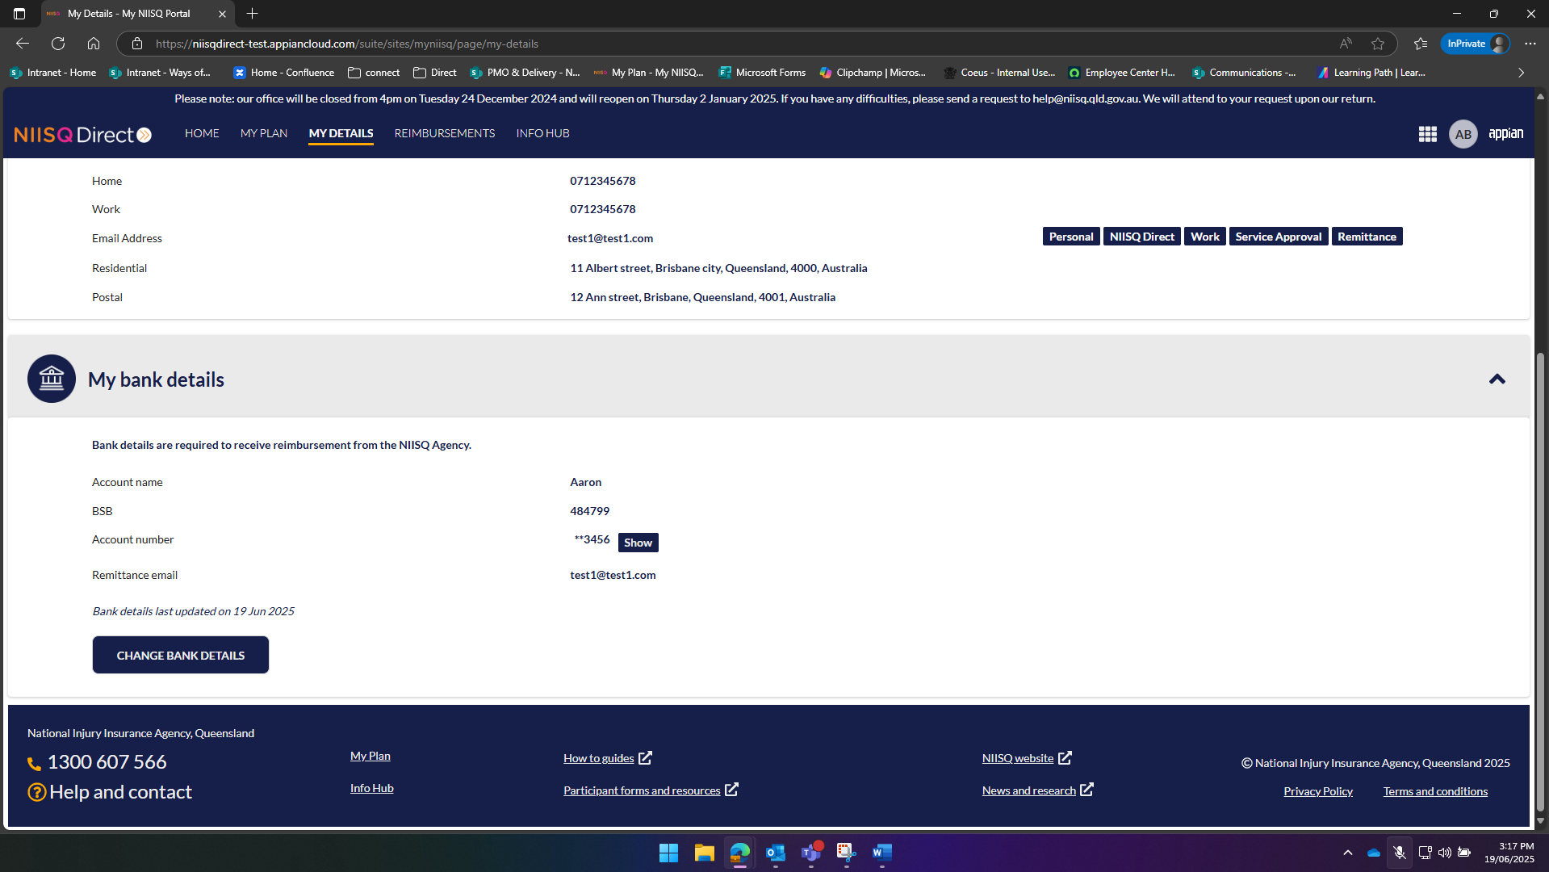
My contact details are out of date; how do I update them?
If you notice that your contact details are out of date, please email us at help@niis.qld.gov.au explaining what details need to be updated and we’ll organise that for you.

Important note: How to fix your contact details if they are not correct.
If your contact details are not correct, please send an email to help@niis.qld.gov.au.
Let us know what needs to be changed, and we will help update them for you.
Optional: editing your bank details
- If you want to edit your details, simply click the edit button (hint: it looks like a pencil).
- Once you’re finished updating your details, click
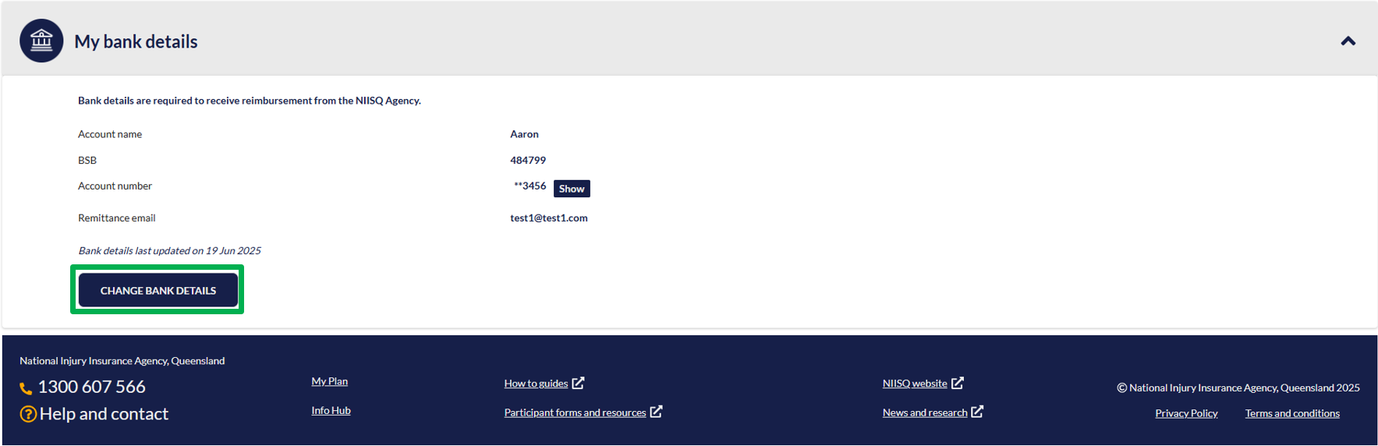
Important note: I have a yellow box saying I can’t update my bank details yet – what do I do?
If a payment is already being processed, or if an update to your bank details is already underway, you won’t be able to change your bank details here. To make sure your payment goes to the correct bank account, please contact us at help@niis.qld.gov.au so we can update our records for you.

Need help?
If you need help at any time:
- Email us at help@niis.qld.gov.au. We’ll get back to you as soon as possible.
- You can also ask someone you trust to help you with this guide.

Digital ID hints and tips
NIISQ Direct uses Digital ID to securely sign you into our portal. This is used by Australian and Queensland government agencies and providers and helps you to access your information.
Please note, NIISQ Direct does not accept QGOV or QDI digital IDs.
What is a Digital ID?
- A Digital ID is a secure and easy way to prove who you are online.

What if I don’t have a Digital ID?
- If you don’t currently have a Digital ID, you’ll need to create one before you can login to NIISQ Direct.
- It’s free and easy to do.
- Go to https://www.qld.gov.au/qdifaq for advice on how to set up a Digital ID with a digital ID provider.
What is an identity strength?
- Identity strength is like a trust level for your Digital ID. It's a way of showing how sure the system is that you are who you say you are.
- To be able to sign into NIISQ Direct, your identity strength needs to be set as ‘standard’ or higher.

