**Getting started: How to use the reimbursements section**  
  
Welcome! This guide will help you submit a reimbursement on NIISQ Direct. It’s easy to follow, and you can go at your own pace. If you need help, a support person or trusted friend can follow along with you.

**What you’ll need:**  
  
Before you begin, make sure you have the following ready:

* A device connected to the internet (like a phone, tablet, or computer)
* Your smart device with the Digital ID app
* Your Digital ID email address  
  *If you are unsure what a Digital ID is, there is some information at the end of this guide.

Tip: If you have someone who helps you with online tasks, you might want to ask them to go through this guide with you.

**Step-by-step: How to submit a reimbursement**  
Follow each step below.   
  
**Step 1: Go to the website**

* Open your internet browser (like Chrome, Safari, or Edge)
* Type in the website address: <https://niis.qld.gov.au/niisq-direct>.
* Press Enter on your keyboard.

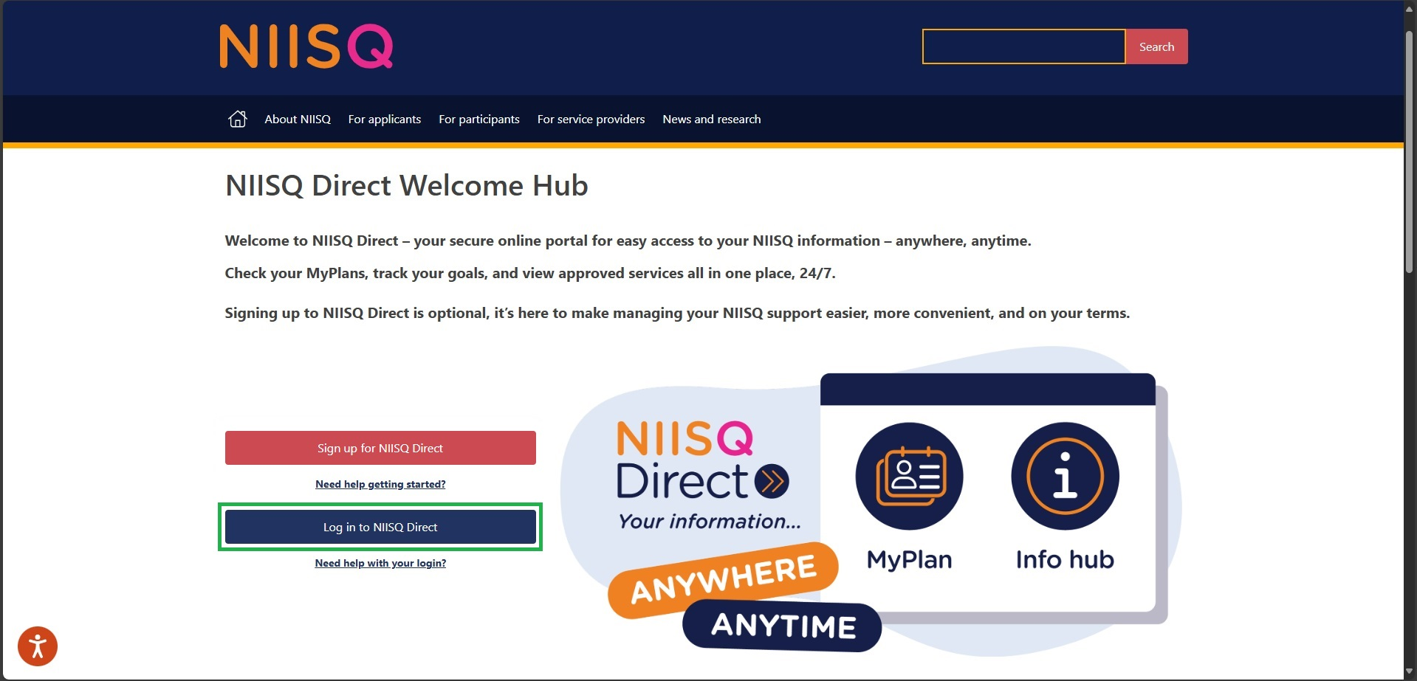

**Step 2: Log in to your NIISQ Direct account**

* Look for a button that says “Log in to NIISQ Direct”
* Click the button once.



**Step 3: Go to the Reimbursements section**

* To access the Reimbursements section, click on the “Reimbursements” tile on NIISQ Direct’s home page
* **A screenshot of a computer

  AI-generated content may be incorrect.**You can also click on the “Reimbursements” tab at the top of the screen. Either way is ok!

**Step 4: Start a new reimbursement**

* Click ‘**+ New reimbursement**’ beside the plan dates you’re claiming a reimbursement for.

**Step 5: Select who is receiving the reimbursement**

* Select the person who is receiving the reimbursement from the available options
* **A white background with red text

  AI-generated content may be incorrect.**If the required person is not listed, please contact your Support Planner/team to discuss.

**Step 6: Select bank account details**

* If you are sure we already have the correct bank account details for the reimbursee (the person who is receiving the reimbursement), click “use the details previously provided”
* **A screenshot of a computer

  AI-generated content may be incorrect.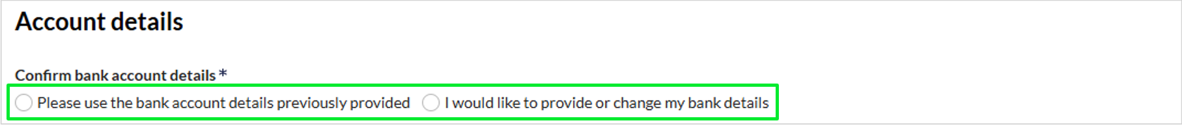**If you haven’t given us any bank account details yet, or they have changed (or you just want to check what details we have), select “add new details”.

**Step 7: Select the service the reimbursement is for**

* When selecting the reimbursee (the person who is receiving the reimbursement), the available service categories will change according to what’s approved in your MyPlan
* If the reimbursement is for travel, select ‘Participant related travel’
* If the required service is not listed, or you’re not sure which category to choose, select ‘other’.

**Step 8: Fill in the form**

* Complete all required fields of the form and upload a receipt if required
* To upload a receipt, either click the upload button or drag and drop the file to the upload box
* You can add multiple items to your reimbursement request.

**Step 9: Submit the form**

* Once the form is complete and you’re ready to submit, review the details you’ve entered
* If everything is correct, read and click on the end statement check box
* **A screenshot of a computer

  AI-generated content may be incorrect.**Click Submit reimbursement.

**Step 10: Submit your feedback (or skip)**

* Once you’ve submitted the reimbursement request, an optional feedback survey will open up
* If you would like to provide feedback, please select a rating and enter in your comments (if any)
* If you would prefer not to provide any feedback, select ‘skip’.

**Optional: Save and close**

* If you’re not ready to submit your reimbursement request for whatever reason, click save and close.
* This will save your progress and allow you to come back to it later!

**Optional: View previous drafts and submissions**

* You can see previously submitted and drafted reimbursements under ‘My reimbursements’
* You can view the details of submitted and drafted reimbursements by clicking the binoculars icon (where it says ‘view’).

**Optional: Edit and submit a draft**

* You can edit a draft by clicking the pencil icon (where it says ‘edit’)
* **A screenshot of a computer

  AI-generated content may be incorrect.**Once ready, you can submit the draft reimbursement (which we explain how to do in Step 9).

**Need help?**  
If you need help at any time:

* Email us at [help@niis.qld.gov.au](mailto:help@niis.qld.gov.au). We’ll get back to you as soon as possible
* You can also ask someone you trust to help you with this guide.

**Digital ID hints and tips**

NIISQ Direct uses Digital ID to securely sign you into our portal. This is used by Australian and Queensland government agencies and providers and helps you to access your information.

Please note, NIISQ Direct does not accept QGOV or QDI digital IDs.

**What is a Digital ID?**

* A Digital ID is a secure and easy way to prove who you are online.

**What if I don’t have a Digital ID?**

* If you don’t currently have a Digital ID, you’ll need to create one before you can login to NIISQ Direct.
* It’s free and easy to do.
* Go to <https://www.qld.gov.au/qdifaq> for advice on how to set up a Digital ID with a digital ID provider.

**What is an identity strength?**

* Identity strength is like a trust level for your Digital ID. It's a way of showing how sure the system is that you are who you say you are.
* To be able to sign into NIISQ Direct, your identity strength needs to be set as ‘standard’ or higher.