Getting started: How to sign up to NIISQ Direct
Welcome! This guide will help you sign up to NIISQ Direct for the first time. We’ll go step-by-step, in clear and simple language.

What you’ll need:
Before you begin, make sure you have the following ready:
- A device connected to the internet (like a phone, tablet, or computer)
- Your NIISQ case number
- Your Digital ID email address
*If you are unsure what a Digital ID is, there is some information at the end of this guide.
- A contact email address (this can be the same as your Digital ID email address)
- If you are signing up on behalf of the NIISQ participant, you will need their full legal name.
Tip: If you have someone who helps you with online tasks, you might want to ask them to go through this guide with you.

Step-by-step: How to sign up
Follow each step below.
Step 1: Go to the website
- Open your internet browser (like Chrome, Safari, or Edge)
- Type in the website address: https://niisqdirect-portals.niis.qld.gov.au/sign-up-form.
- Press Enter on your keyboard.
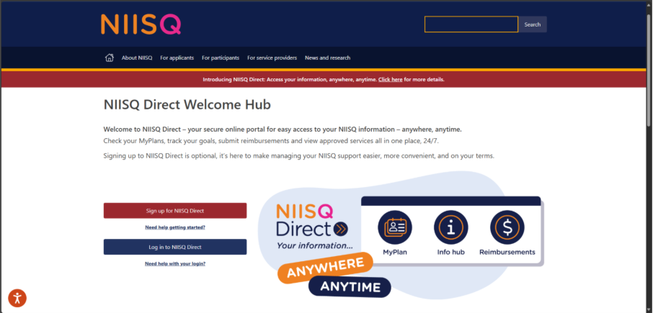
Step 2: Click “Sign up for NIISQ Direct”
- Look for a button that says “Sign up for NIISQ Direct”
- Click the button once.
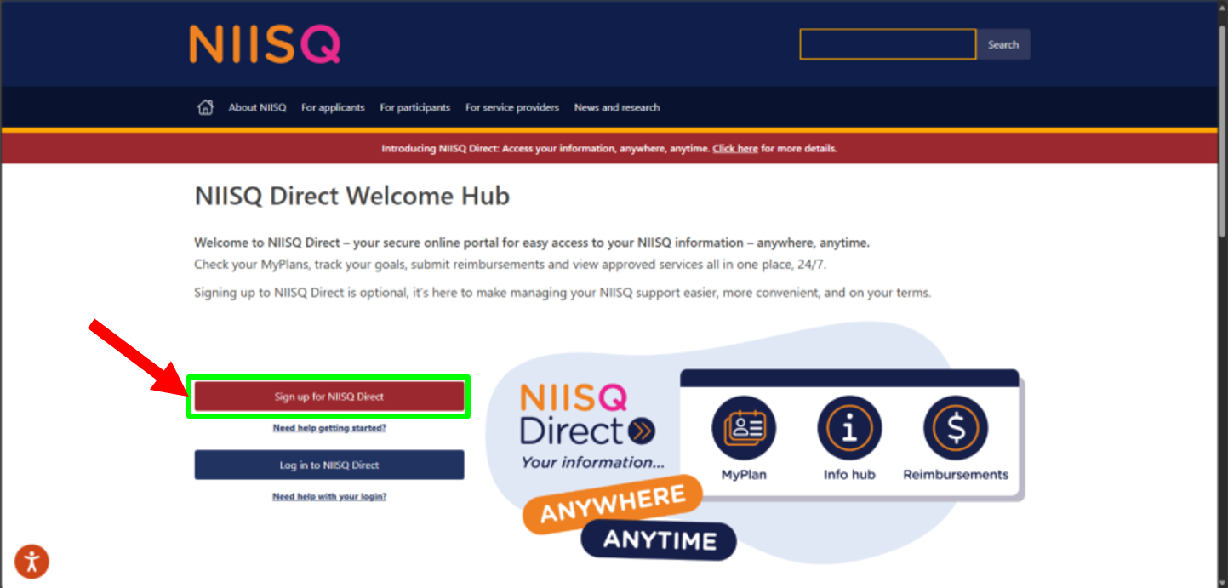

Step 3: Fill in your details
- Type in your name, Digital ID email, NIISQ case number and any other requested information.
- When all details have been added, click the button that says “Submit”.
- The NIISQ Direct team will send you an email in the coming days letting you know if your sign up has been successful or if we need to check some details with you.
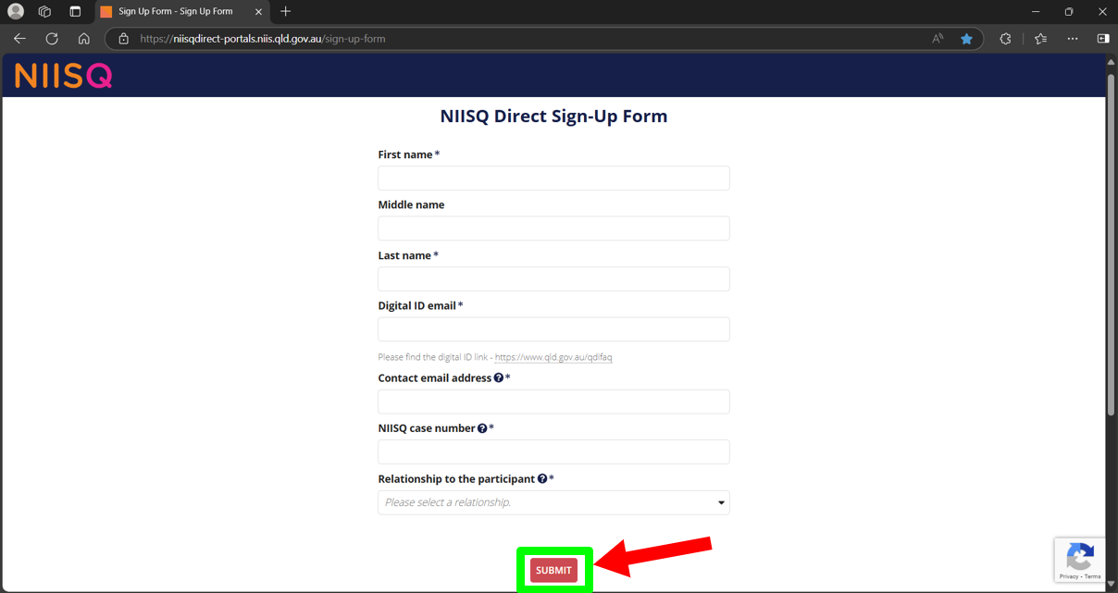

Need help?
If you need help at any time:
- Email us at help@niis.qld.gov.au. We’ll get back to you as soon as possible.
- You can also ask someone you trust to help you with this guide.

Digital ID hints and tips
NIISQ Direct uses Digital ID to securely sign you into our portal. This is used by Australian and Queensland government agencies and providers and helps you to access your information.
Please note, NIISQ Direct does not accept QGOV or QDI Digital IDs.
What is a Digital ID?
- A Digital ID is a secure and easy way to prove who you are online.

What if I don’t have a Digital ID?
- If you don’t currently have a Digital ID, you’ll need to create one before you can log in to NIISQ Direct.
- It’s free and easy to do.
- Go to https://www.qld.gov.au/qdifaq for advice on how to set up a Digital ID with a Digital ID provider.
What is an identity strength?
- Identity strength is like a trust level for your Digital ID. It's a way of showing how sure the system is that you are who you say you are.
- To be able to sign into NIISQ Direct, your identity strength needs to be set as ‘standard’ or higher.

